Opportunity Main Form
Added a section, tied it to the Topic field, and added a Canvas app control:
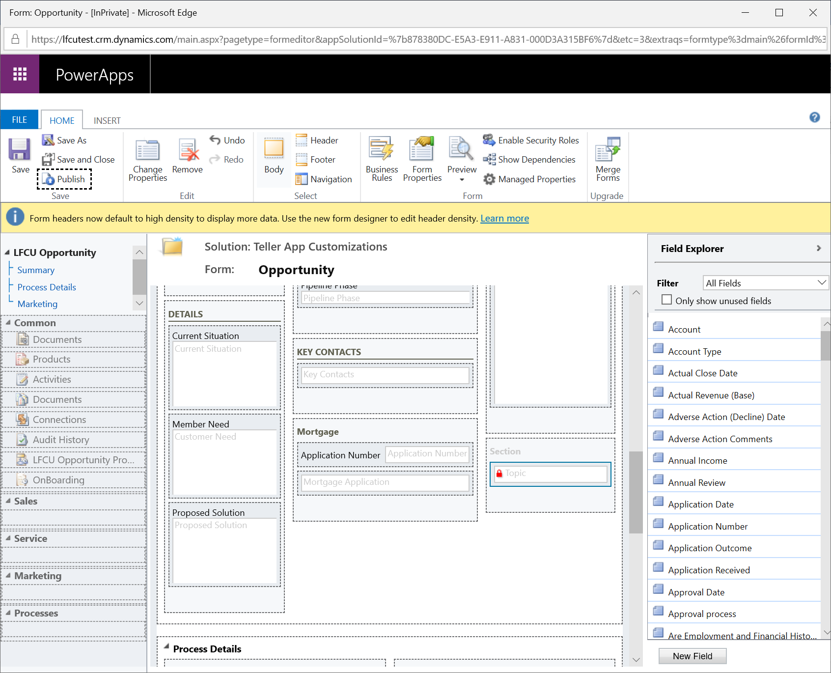
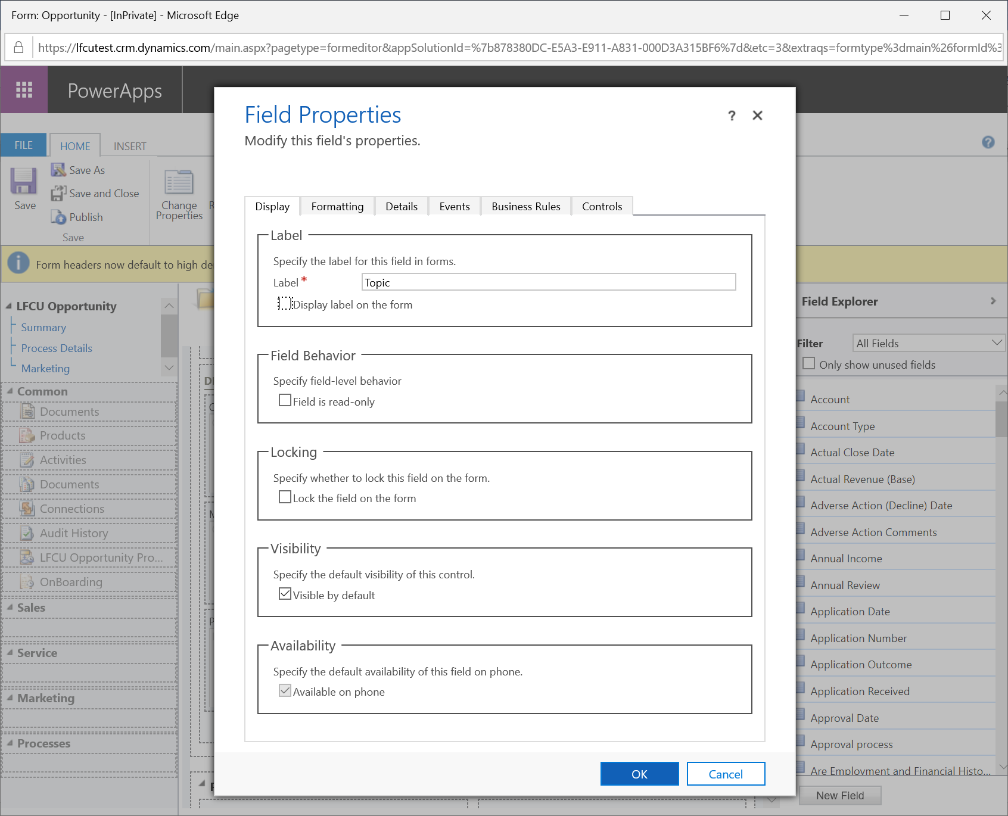
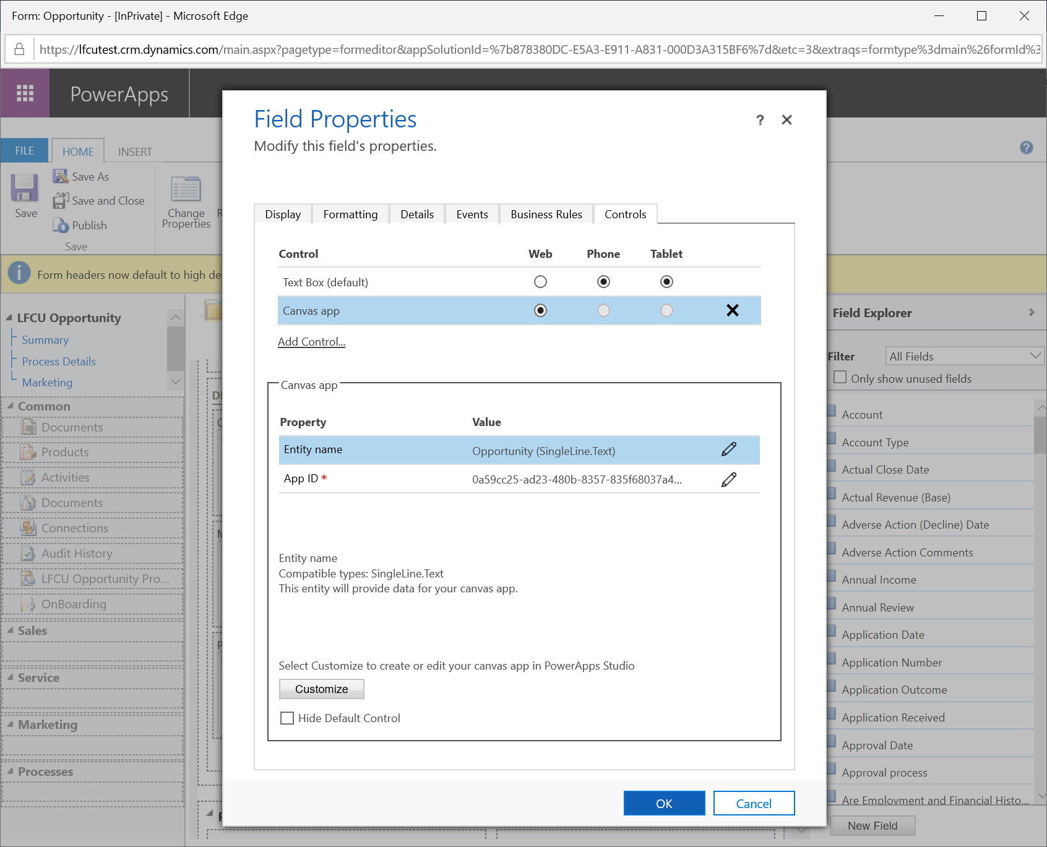
In the app, I am fetching the complete Opportunity record first using the ModelDrivenFormIntegration
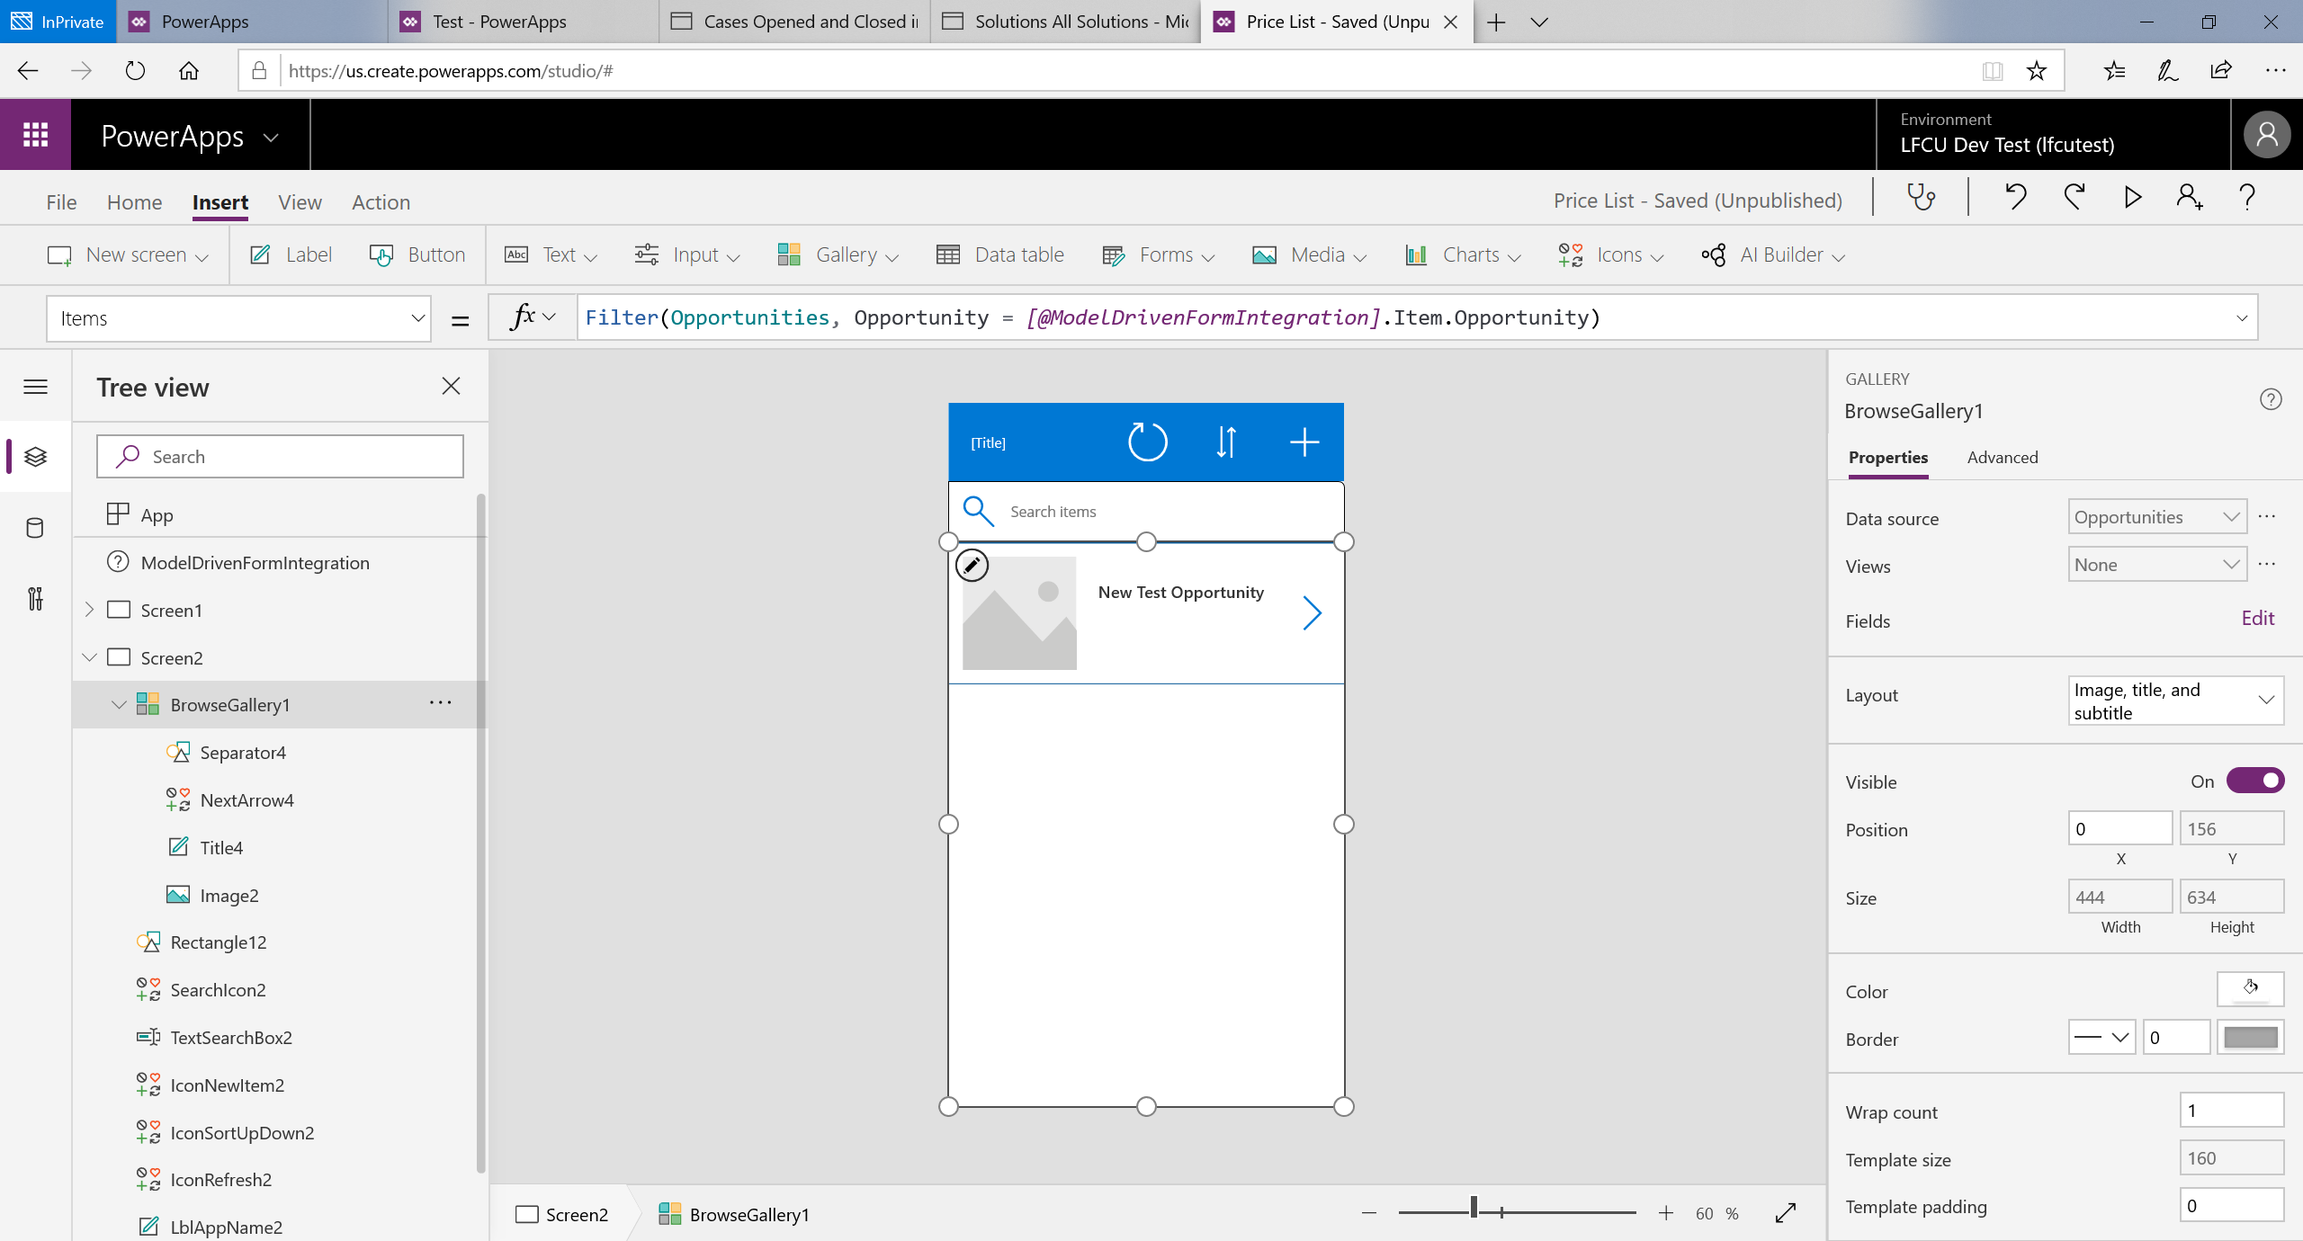
Then in another gallery in the 1st screen, I am using this Opportunity gallery to display the Price Lists
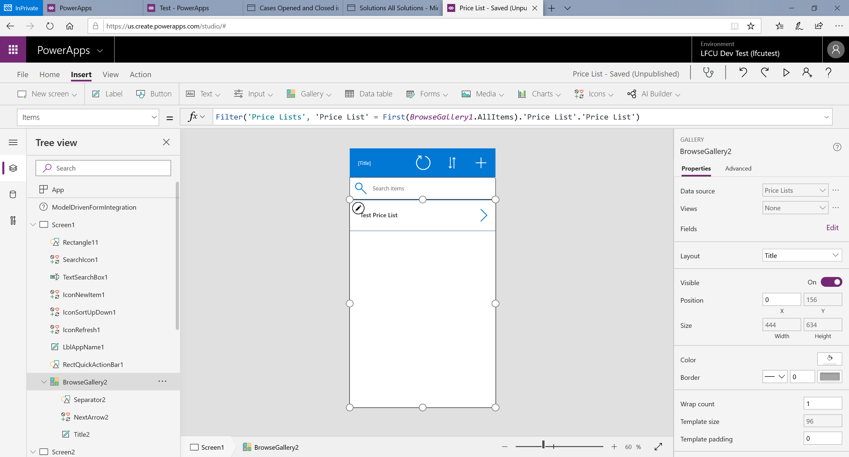
And here is my canvas app in the Opportunity Main Form
