CDS Data – Dates:
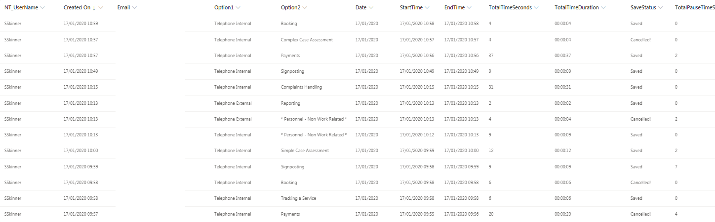

Exported from CDS – To Excel:
