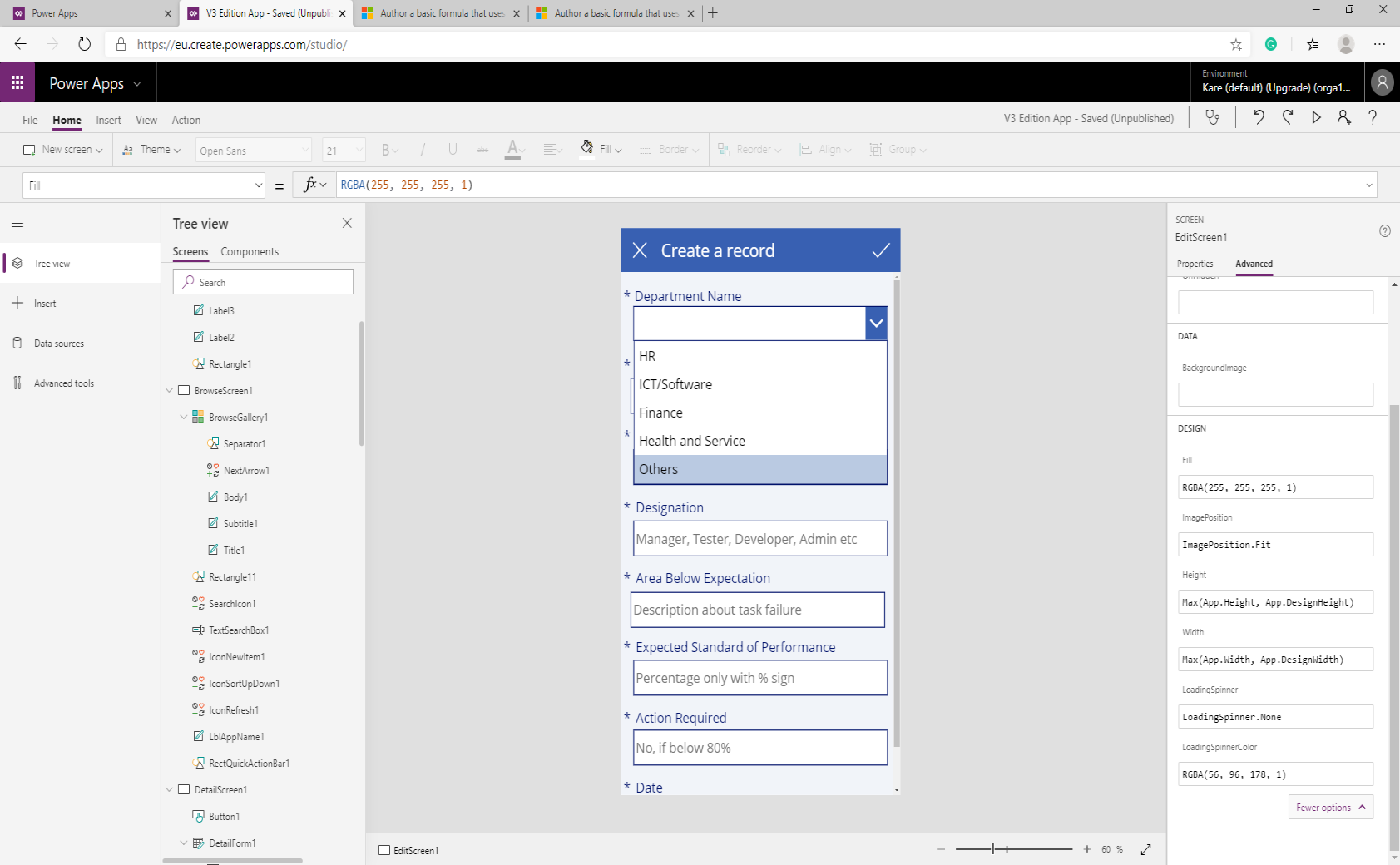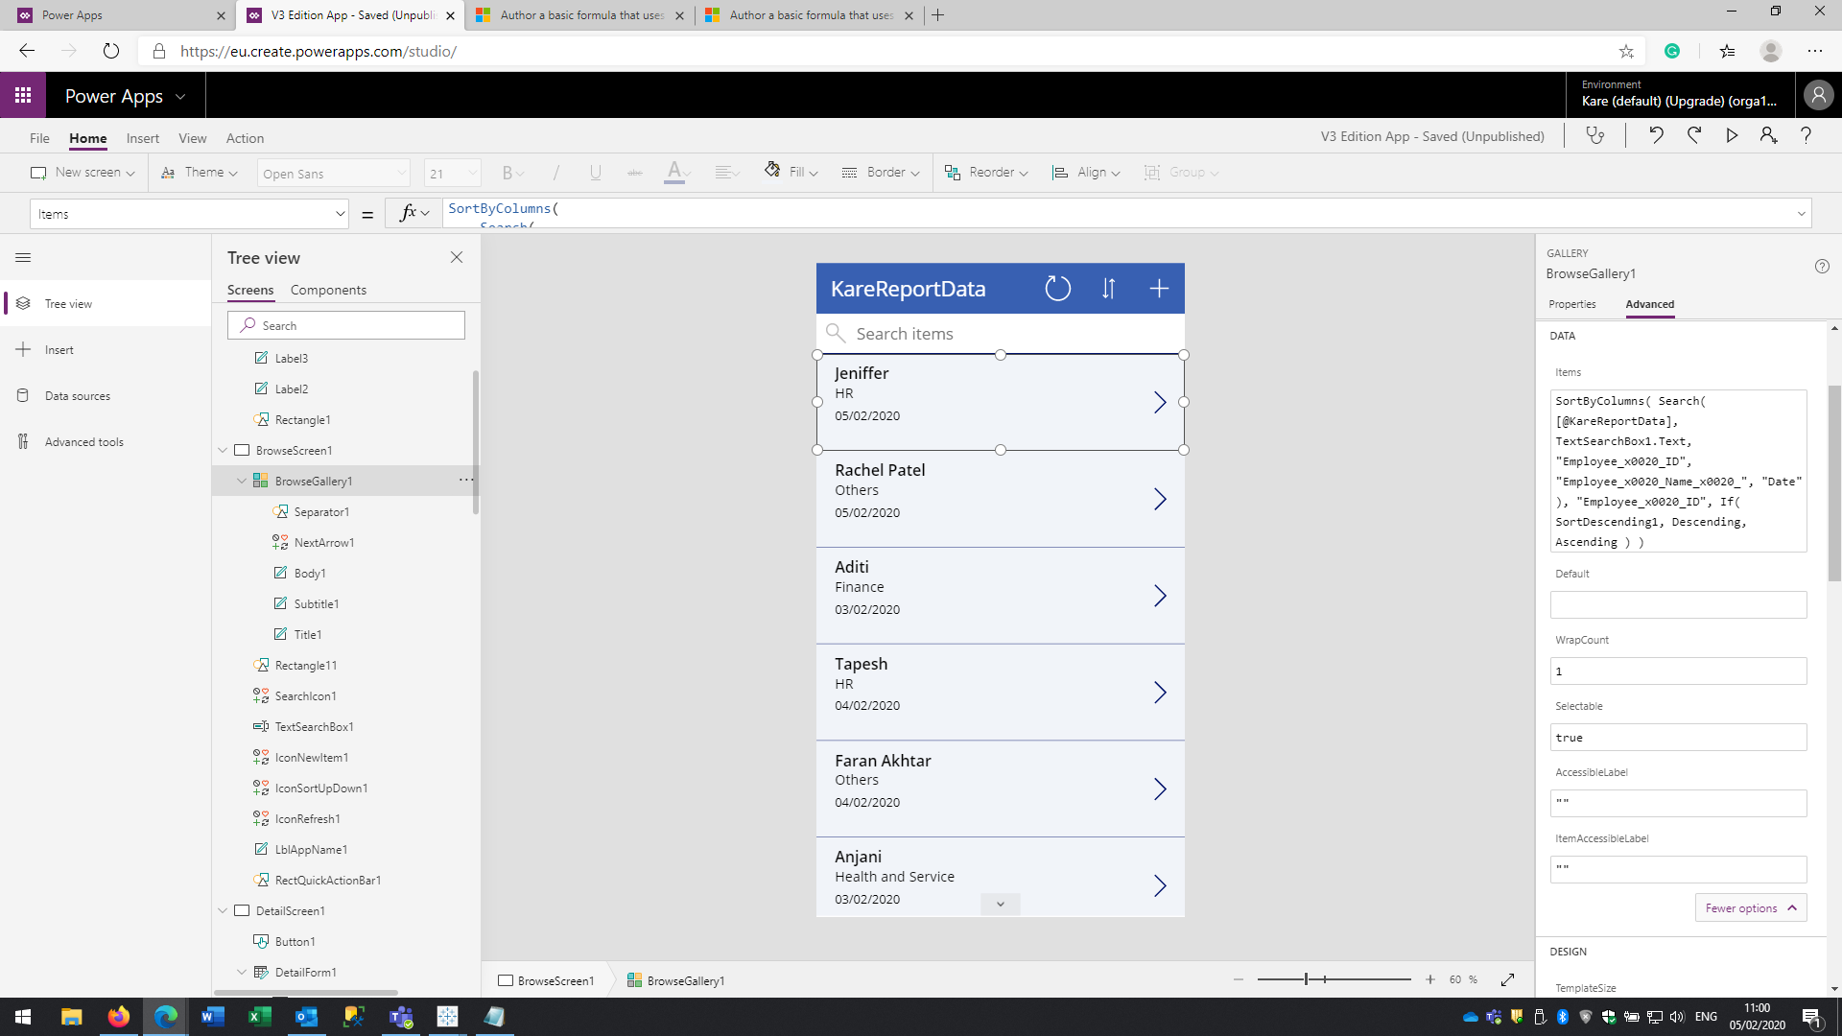

Step 2 when I Select value i.e. Others

Step 1, when I click +

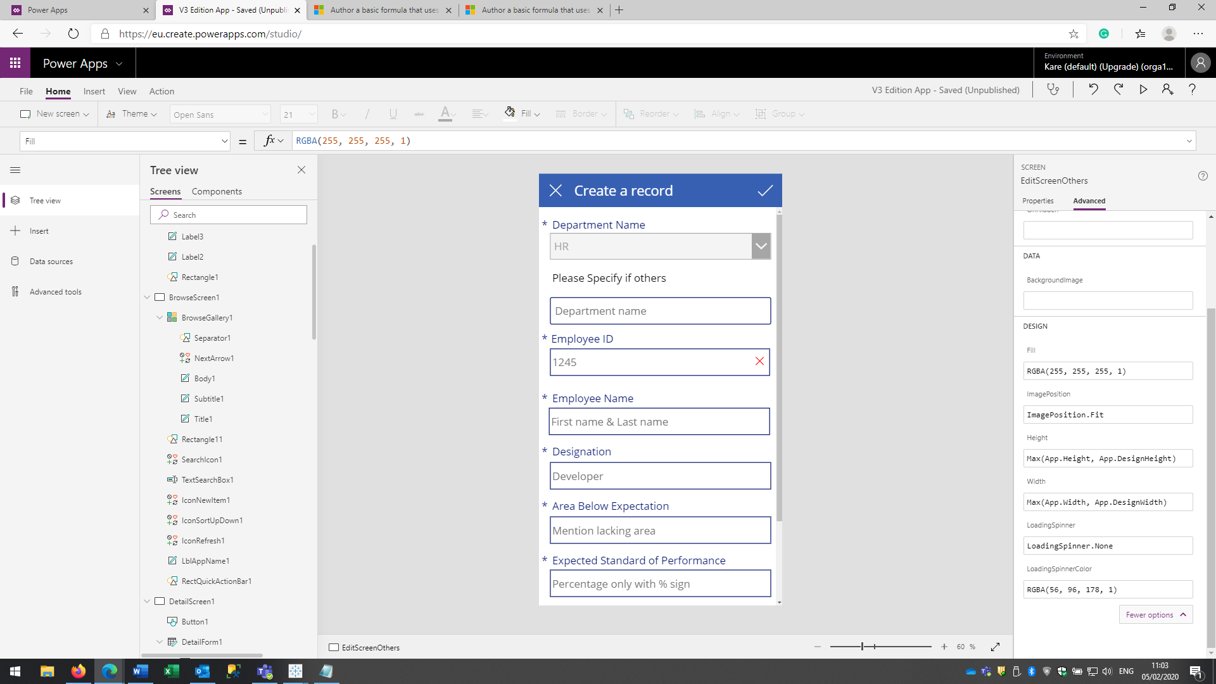

Step 3, Error the selected value is HR. WHY?