The LookUp function to save user_id should not be an issue as I have used it in another flow for insertion into database which works perfectly fine.
However, I changed that value and yet user_skills does not get populated on app start or on visible portion of screen.
1st attempt: Using flow
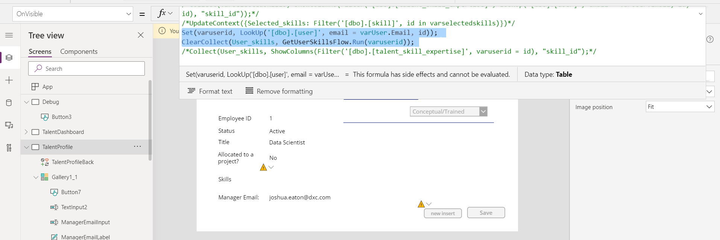

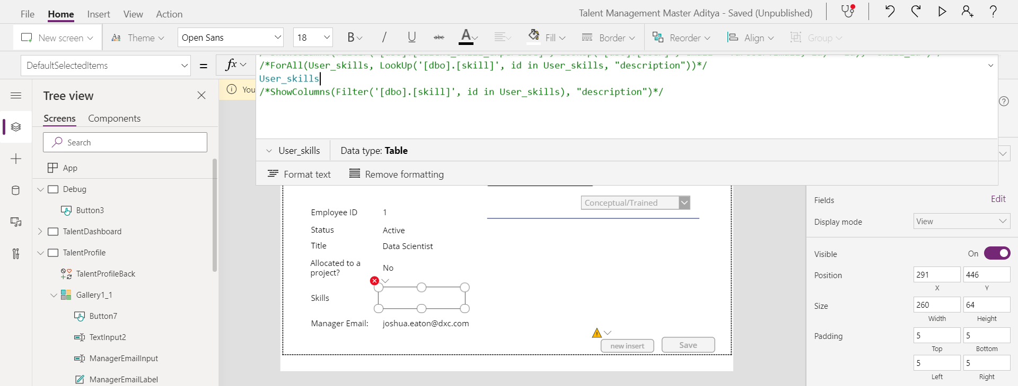
User_skills is supposed to extract values from database and fill the collection but is empty
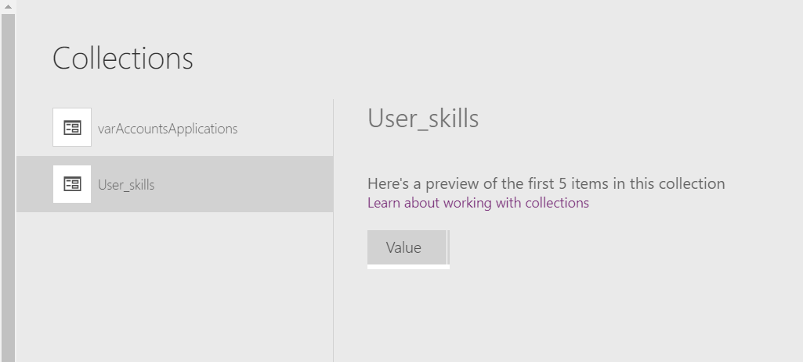
2nd attempt: Not using flow
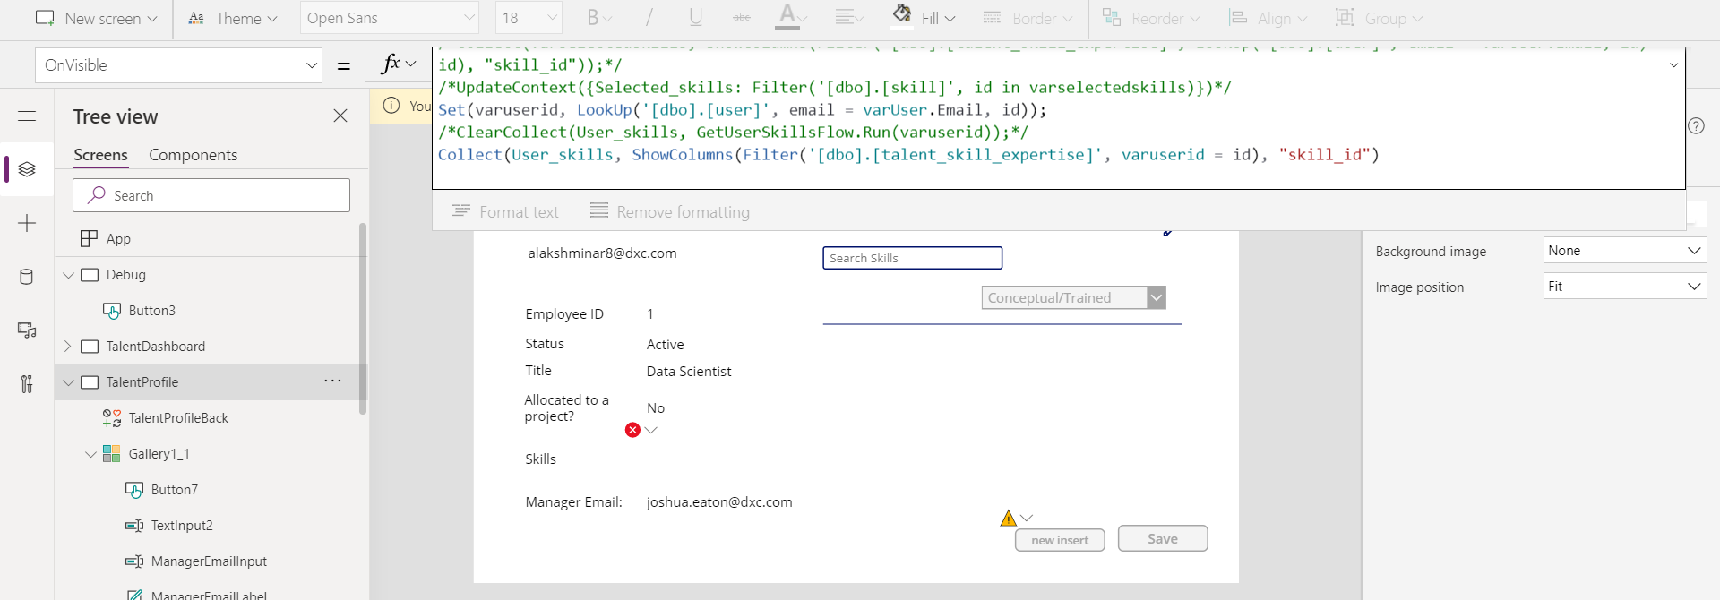
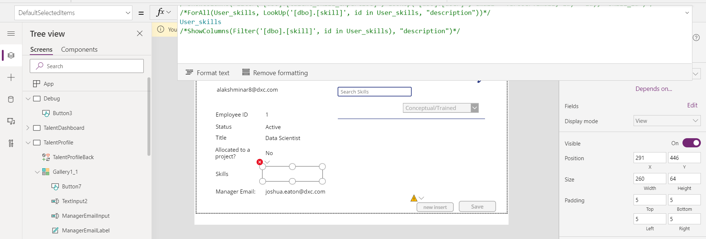
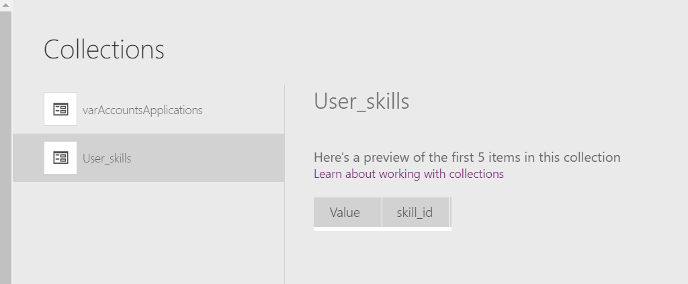
Instead of using the collection(which has the skill ID) in default selected items of the combobox, I also used a different method to extract the skill name directly which also did not work
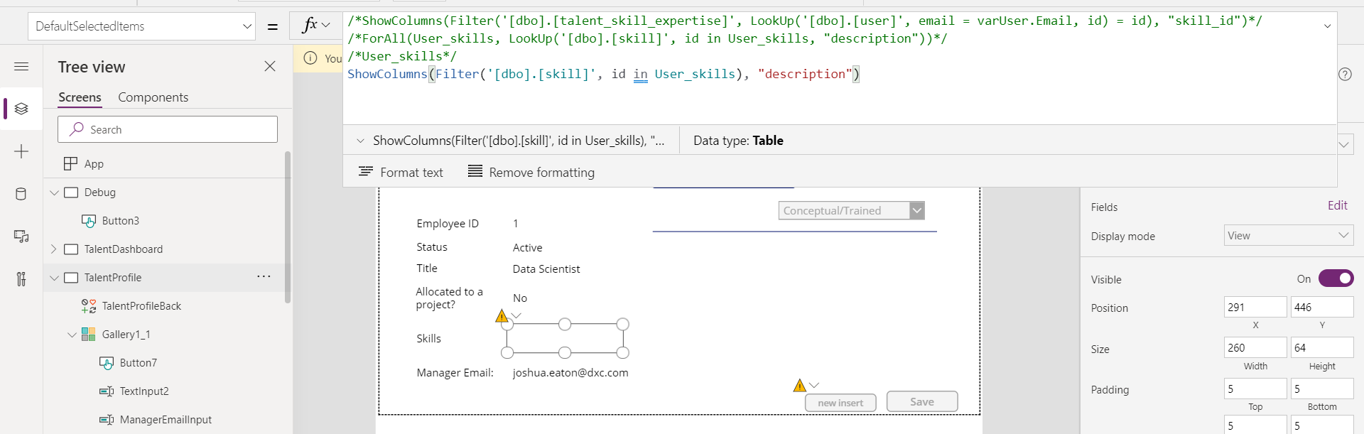
I tried doing the same by shifting the ‘OnVisible’ collect statements to ‘new insert’ button but user_skills are not yet populated.
Most direct approach to populate combobox
