There are 3 input parts to the form parts to the form (Detail1,2,3)
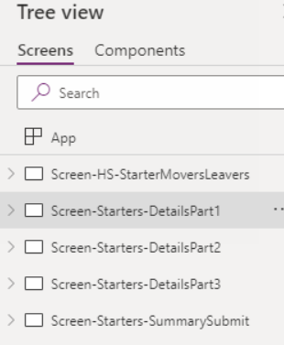
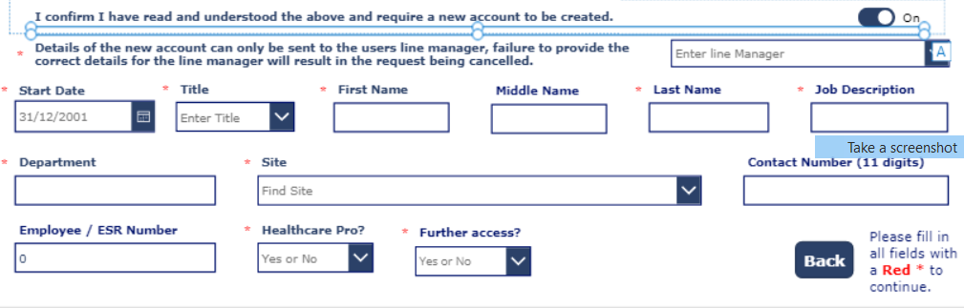

My expectation is that the default error message should be displayed beneath all data cards. OnStart, by default.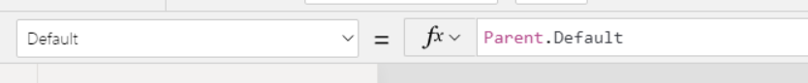

Once all required fields are filled in the Continue Button Appears:

I hide the Asterix using this function: If(IsBlank('DataCardValue-FirstName'),true,false) – I have basically skipped the Error Message because I don’t know what is wrong. I’d like to know.
This works for all the text boxes (Asterix, appears, disappears, appears depending on if blank or not) – but with the dropdowns if you select a value Asterix disappears, but never reappears if I end up undeleting result.

e.g.
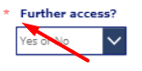
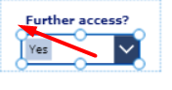
Clear Yes – Asterix does not reappear unlike the Text boxes.
